**Git tag:**

* Tag is a pointer to commit
* A tag is like a branch that doesn’t change. Unlike branches, tags, after being created, have no further history of commits
* For every release, we have tags, if can roll back to the particular tag
* Branch automatically moves when we make new commit
* When we create a tag, it will create to the latest commit
* We can pull the code up to specific tag. Tag names adds to the latest commit

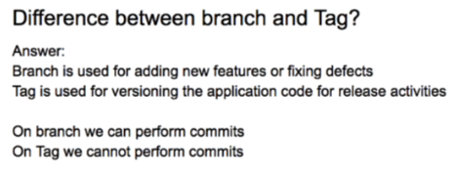

**Types of tags:**

1. Annotated tags
2. Lightweight tags

**Annotated tags:**

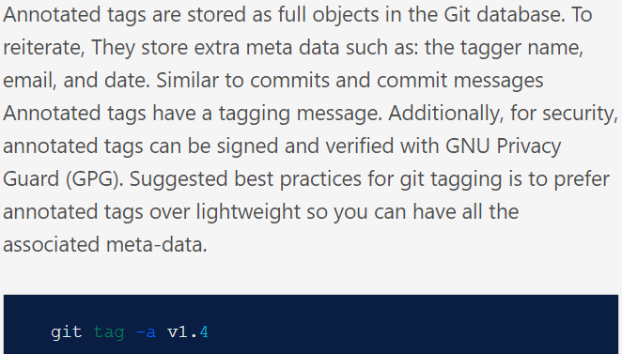

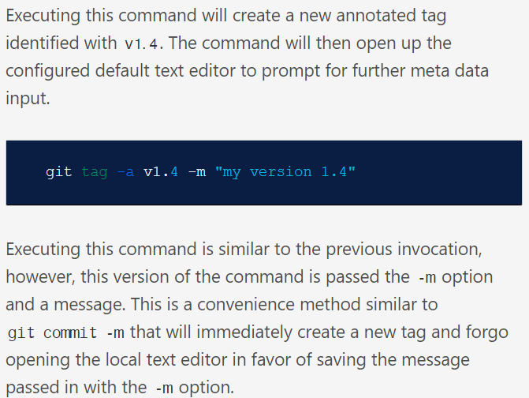

**Lightweight tags:**

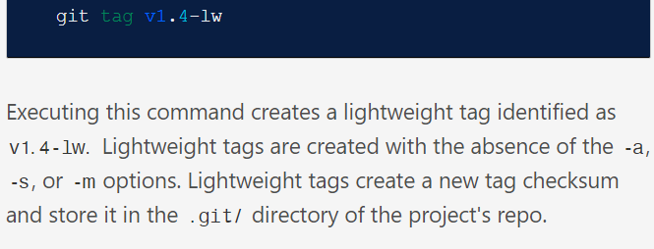

**Commands:**

**Git tag v1.0**

* To create the tag

**Git tag -a v1.1 -m “message”**

* To create the tag with message

**Git tag**

* To see the tags

**git tag -l *-rc\***

* to filter the tags. We need to use “-l” option as above

**Git show <tag_name>**

* To see the details of particular tag

**Git push origin <tag name>**

* To push the tag to remote repo

After pushing, it will create a release in github

**Git push –tags**

* To push all the tags

**Git tag -d <tag name>**

**Git tag –delete <tag name>**

**Git tag -d <tag name> <tag name> 🡪 for multiple tags**

* To delete the tag locally

**Git push origin -d <tag name>**

**Git push origin –delete <tag name>**

**Git push origin –delete <tag name> <tag name> 🡪 for multiple tags**

* To delete the tags from remote repo

**Git tag <tag name> <commit id>**

* To create tag for older commits

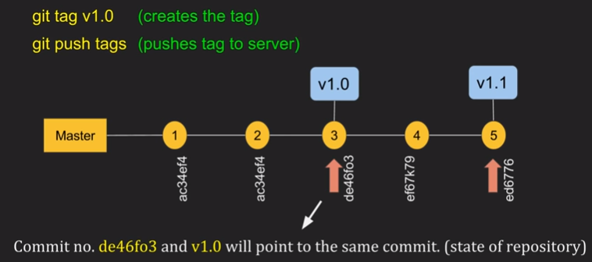

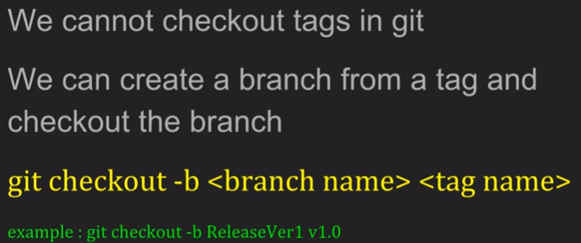

**Renaming tag:**

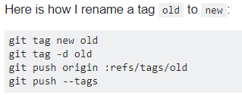

**Replacing or retagging the old tags:**

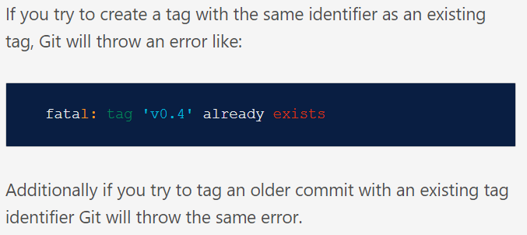

**Checkout the tags:**

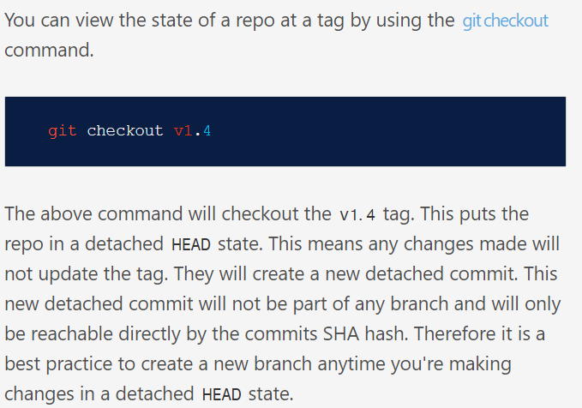

* **git checkout tags/<tag> -b <branch>**

**Deleting tags:**

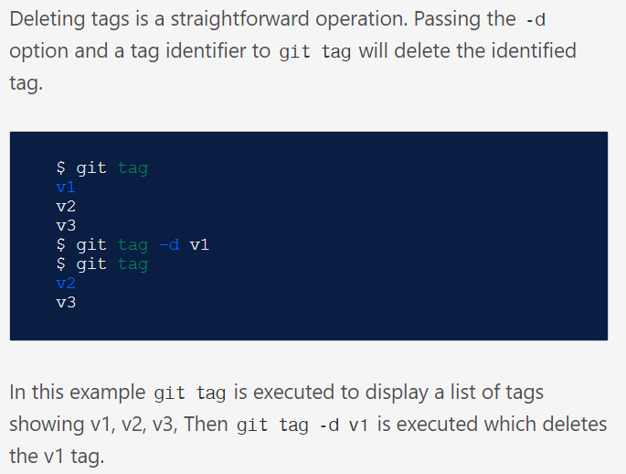

We can also have multiple tags on a single commit ID as below.

